

**Khulna University of Engineering & Technology, Khulna**

Department of

Electronics & Communication Engineering

Project Report on:

***Designing an E-Commerce Website using HTML, CSS, JavaScript,ASP.NET***

Course No: **CSE 3100**

Course Title: **Internet Programming Laboratory**

Submitted By

**Md Sajib Rahman**

Roll:**1909028**

Year:3rd Term: 1st

Submitted To

**Md Nazirul Hasan Shawon**

Lecturer

Dept. of CSE, KUET

**Md. Repon Islam**

Lecturer

Dept. of CSE, KUET

**Objective:**

To create a Curiculum Vitae using HTML & CSS.

**Theory:**

HTML, or **HyperText Markup Language**, is the standard language for creating web pages. It uses tags to define the structure and content of a webpage. Elements like headings, paragraphs, images, and links are crucial components. Tags come in pairs, with an opening and closing tag. Attributes provide additional information about elements. A typical HTML document includes a declaration, `<html>`, `<head>` (for metadata), and `<body>` (for main content). Hyperlinks are created using `<a>` tags. Images are added with `<img>` tags, specifying a source (src) attribute. Lists can be ordered `<ol>` or unordered `<ul>`, both using `<li>` for list items. HTML5 introduced semantic elements like `<header>`, `<footer>`, `<section>`, `<article>`, and `<nav>`.

CSS, or **Cascading Style Sheets,** is a vital web technology. It complements HTML by styling web pages, controlling elements' appearance like colors, fonts, and layout. CSS rules consist of selectors (targeting elements) and properties (defining appearance). Syntax involves curly braces and property-value pairs. The "cascade" resolves conflicting styles from various sources. Inheritance allows child elements to adopt parent styles unless overridden. The box model governs an element's space with properties like margin, border, and padding. Different units like pixels, em, and percentages offer layout flexibility. Media queries enable responsive design for various screen sizes. CSS frameworks like Bootstrap and preprocessors like Sass enhance styling capabilities.

**JavaScript** is a widely-used programming language for web development. It enables interactivity, dynamic content, and DOM manipulation on websites. Created by Brendan Eich in 1995, it was initially called Mocha before being renamed JavaScript. It's distinct from Java, despite the similar name. JavaScript works in conjunction with HTML and CSS to create interactive web pages. It's an interpreted language, allowing for quick development without compilation. With Node.js, JavaScript can also be used for server-side scripting. The language boasts a rich ecosystem of libraries and frameworks like React and Angular. JavaScript is foundational in modern web development, powering many popular websites and applications.

**ASP.NET** is a web application framework developed by Microsoft. It enables developers to build dynamic, robust, and scalable web applications and services. It's a part of the larger .NET platform, providing a powerful environment for server-side scripting and web development. ASP.NET supports multiple programming languages, including C# and VB.NET, offering flexibility to developers. It utilizes a Model-View-Controller (MVC) architecture, promoting organized and maintainable code. ASP.NET also includes Web Forms, a technology for creating web pages with a drag-and-drop interface. It integrates seamlessly with other Microsoft technologies and tools, enhancing productivity for developers in the Microsoft ecosystem. ASP.NET Core, a cross-platform and open-source version, extends the framework's capabilities to non-Windows environments. It's widely used in enterprise-level applications, powering various websites and web services across different industries.

**Software used:**

Visual Studio 2022

**Code:**

**Homepage:**

<%@ Page Title="" Language="C#" MasterPageFile="~/User/User.Master" AutoEventWireup="true" CodeBehind="Default.aspx.cs" Inherits="TechWorld.User.Default" %>

<asp:Content ID="Content1" ContentPlaceHolderID="head" runat="server">

</asp:Content>

<asp:Content ID="Content2" ContentPlaceHolderID="ContentPlaceHolder1" runat="server">

<!-- offer section -->

<section class="offer_section layout_padding-bottom">

<div class="offer_container">

<div class="container ">

<div class="row">

<div class="col-md-6 ">

<div class="box ">

<div class="img-box">

<img src="images/.jpg" alt="">

</div>

<div class="detail-box">

<h5>

iphone Special

</h5>

<h6>

<span>10%</span> Off

</h6>

<a href="">

Shop Now <svg version="1.1" id="Capa_1" xmlns="http://www.w3.org/2000/svg" xmlns:xlink="http://www.w3.org/1999/xlink" x="0px" y="0px" viewBox="0 0 456.029 456.029" style="enable-background:new 0 0 456.029 456.029;" xml:space="preserve">

<g>

<g>

<path d="M345.6,338.862c-29.184,0-53.248,23.552-53.248,53.248c0,29.184,23.552,53.248,53.248,53.248

c29.184,0,53.248-23.552,53.248-53.248C398.336,362.926,374.784,338.862,345.6,338.862z" />

</g>

</g>

<g>

<g>

<path d="M439.296,84.91c-1.024,0-2.56-0.512-4.096-0.512H112.64l-5.12-34.304C104.448,27.566,84.992,10.67,61.952,10.67H20.48

C9.216,10.67,0,19.886,0,31.15c0,11.264,9.216,20.48,20.48,20.48h41.472c2.56,0,4.608,2.048,5.12,4.608l31.744,216.064

c4.096,27.136,27.648,47.616,55.296,47.616h212.992c26.624,0,49.664-18.944,55.296-45.056l33.28-166.4

C457.728,97.71,450.56,86.958,439.296,84.91z" />

</g>

</g>

<g>

<g>

<path d="M215.04,389.55c-1.024-28.16-24.576-50.688-52.736-50.688c-29.696,1.536-52.224,26.112-51.2,55.296

c1.024,28.16,24.064,50.688,52.224,50.688h1.024C193.536,443.31,216.576,418.734,215.04,389.55z" />

</g>

</g>

<g>

</g>

<g>

</g>

<g>

</g>

<g>

</g>

<g>

</g>

<g>

</g>

<g>

</g>

<g>

</g>

<g>

</g>

<g>

</g>

<g>

</g>

<g>

</g>

<g>

</g>

<g>

</g>

<g>

</g>

</svg>

</a>

</div>

</div>

</div>

<div class="col-md-6 ">

<div class="box ">

<div class="img-box">

<img src="images/o2.jpg" alt="">

</div>

<div class="detail-box">

<h5>

For Pixel Lover

</h5>

<h6>

<span>15%</span> Off

</h6>

<a href="">

Shop Now <svg version="1.1" id="Capa_1" xmlns="http://www.w3.org/2000/svg" xmlns:xlink="http://www.w3.org/1999/xlink" x="0px" y="0px" viewBox="0 0 456.029 456.029" style="enable-background:new 0 0 456.029 456.029;" xml:space="preserve">

<g>

<g>

<path d="M345.6,338.862c-29.184,0-53.248,23.552-53.248,53.248c0,29.184,23.552,53.248,53.248,53.248

c29.184,0,53.248-23.552,53.248-53.248C398.336,362.926,374.784,338.862,345.6,338.862z" />

</g>

</g>

<g>

<g>

<path d="M439.296,84.91c-1.024,0-2.56-0.512-4.096-0.512H112.64l-5.12-34.304C104.448,27.566,84.992,10.67,61.952,10.67H20.48

C9.216,10.67,0,19.886,0,31.15c0,11.264,9.216,20.48,20.48,20.48h41.472c2.56,0,4.608,2.048,5.12,4.608l31.744,216.064

c4.096,27.136,27.648,47.616,55.296,47.616h212.992c26.624,0,49.664-18.944,55.296-45.056l33.28-166.4

C457.728,97.71,450.56,86.958,439.296,84.91z" />

</g>

</g>

<g>

<g>

<path d="M215.04,389.55c-1.024-28.16-24.576-50.688-52.736-50.688c-29.696,1.536-52.224,26.112-51.2,55.296

c1.024,28.16,24.064,50.688,52.224,50.688h1.024C193.536,443.31,216.576,418.734,215.04,389.55z" />

</g>

</g>

<g>

</g>

<g>

</g>

<g>

</g>

<g>

</g>

<g>

</g>

<g>

</g>

<g>

</g>

<g>

</g>

<g>

</g>

<g>

</g>

<g>

</g>

<g>

</g>

<g>

</g>

<g>

</g>

<g>

</g>

</svg>

</a>

</div>

</div>

</div>

</div>

</div>

</div>

</section>

<!-- end offer section -->

<!-- about section -->

<section class="about_section layout_padding">

<div class="container ">

<%@ Page Title="" Language="C#" MasterPageFile="~/User/User.Master" AutoEventWireup="true" CodeBehind="Default.aspx.cs" Inherits="TechWorld.User.Default" %>

<asp:Content ID="Content1" ContentPlaceHolderID="head" runat="server">

</asp:Content>

<asp:Content ID="Content2" ContentPlaceHolderID="ContentPlaceHolder1" runat="server">

<!-- offer section -->

<section class="offer_section layout_padding-bottom">

<div class="offer_container">

<div class="container ">

<div class="row">

<div class="col-md-6 ">

<div class="box ">

<div class="img-box">

<img src="images/.jpg" alt="">

</div>

<div class="detail-box">

<h5>

iphone Special

</h5>

<h6>

<span>10%</span> Off

</h6>

<a href="">

Shop Now <svg version="1.1" id="Capa_1" xmlns="http://www.w3.org/2000/svg" xmlns:xlink="http://www.w3.org/1999/xlink" x="0px" y="0px" viewBox="0 0 456.029 456.029" style="enable-background:new 0 0 456.029 456.029;" xml:space="preserve">

<g>

<g>

<path d="M345.6,338.862c-29.184,0-53.248,23.552-53.248,53.248c0,29.184,23.552,53.248,53.248,53.248

c29.184,0,53.248-23.552,53.248-53.248C398.336,362.926,374.784,338.862,345.6,338.862z" />

</g>

</g>

<g>

<g>

<path d="M439.296,84.91c-1.024,0-2.56-0.512-4.096-0.512H112.64l-5.12-34.304C104.448,27.566,84.992,10.67,61.952,10.67H20.48

C9.216,10.67,0,19.886,0,31.15c0,11.264,9.216,20.48,20.48,20.48h41.472c2.56,0,4.608,2.048,5.12,4.608l31.744,216.064

c4.096,27.136,27.648,47.616,55.296,47.616h212.992c26.624,0,49.664-18.944,55.296-45.056l33.28-166.4

C457.728,97.71,450.56,86.958,439.296,84.91z" />

</g>

</g>

<g>

<g>

<path d="M215.04,389.55c-1.024-28.16-24.576-50.688-52.736-50.688c-29.696,1.536-52.224,26.112-51.2,55.296

c1.024,28.16,24.064,50.688,52.224,50.688h1.024C193.536,443.31,216.576,418.734,215.04,389.55z" />

</g>

</g>

<g>

</g>

<g>

</g>

<g>

</g>

<g>

</g>

<g>

</g>

<g>

</g>

<g>

</g>

<g>

</g>

<g>

</g>

<g>

</g>

<g>

</g>

<g>

</g>

<g>

</g>

<g>

</g>

<g>

</g>

</svg>

</a>

</div>

</div>

</div>

<div class="col-md-6 ">

<div class="box ">

<div class="img-box">

<img src="images/o2.jpg" alt="">

</div>

<div class="detail-box">

<h5>

For Pixel Lover

</h5>

<h6>

<span>15%</span> Off

</h6>

<a href="">

Shop Now <svg version="1.1" id="Capa_1" xmlns="http://www.w3.org/2000/svg" xmlns:xlink="http://www.w3.org/1999/xlink" x="0px" y="0px" viewBox="0 0 456.029 456.029" style="enable-background:new 0 0 456.029 456.029;" xml:space="preserve">

<g>

<g>

<path d="M345.6,338.862c-29.184,0-53.248,23.552-53.248,53.248c0,29.184,23.552,53.248,53.248,53.248

c29.184,0,53.248-23.552,53.248-53.248C398.336,362.926,374.784,338.862,345.6,338.862z" />

</g>

</g>

<g>

<g>

<path d="M439.296,84.91c-1.024,0-2.56-0.512-4.096-0.512H112.64l-5.12-34.304C104.448,27.566,84.992,10.67,61.952,10.67H20.48

C9.216,10.67,0,19.886,0,31.15c0,11.264,9.216,20.48,20.48,20.48h41.472c2.56,0,4.608,2.048,5.12,4.608l31.744,216.064

c4.096,27.136,27.648,47.616,55.296,47.616h212.992c26.624,0,49.664-18.944,55.296-45.056l33.28-166.4

C457.728,97.71,450.56,86.958,439.296,84.91z" />

</g>

</g>

<g>

<g>

<path d="M215.04,389.55c-1.024-28.16-24.576-50.688-52.736-50.688c-29.696,1.536-52.224,26.112-51.2,55.296

c1.024,28.16,24.064,50.688,52.224,50.688h1.024C193.536,443.31,216.576,418.734,215.04,389.55z" />

</g>

</g>

<g>

</g>

<g>

</g>

<g>

</g>

<g>

</g>

<g>

</g>

<g>

</g>

<g>

</g>

<g>

</g>

<g>

</g>

<g>

</g>

<g>

</g>

<g>

</g>

<g>

</g>

<g>

</g>

<g>

</g>

</svg>

</a>

</div>

</div>

</div>

</div>

</div>

</div>

</section>

<!-- end offer section -->

<!-- about section -->

<section class="about_section layout_padding">

<div class="container ">

<div class="row">

<div class="col-md-6 ">

<div class="img-box">

<img src="./images/about.png" alt="">

</div>

</div>

<div class="col-md-6">

<div class="detail-box">

<div class="heading_container">

<h2>

TechWorld

</h2>

</div>

<p>

Providing latest smartphones with best prices is our first priorities.We do believe in Service not in cheap words.

You can order from anywhere in the country through online. We try to deliver our products as soon as possible.

</p>

<a href="">

Read More

</a>

</div>

</div>

</div>

</div>

</section>

<!-- end about section -->

<!-- client section -->

<section class="client_section layout_padding-bottom">

<div class="container">

<div class="heading_container heading_center psudo_white_primary mb_45">

<h2>

What Says Our Customers

</h2>

</div>

<div class="carousel-wrap row ">

<div class="owl-carousel client_owl-carousel">

<div class="item">

<div class="box">

<div class="detail-box">

<p>

They try to give products with awesome prices... All the staff are very helpful... You can trust them.

</p>

<h6>

Fahad Azom

</h6>

<p>

</p>

</div>

<div class="img-box">

<img src="images/client1.jpg" alt="" class="box-img">

</div>

</div>

</div>

<div class="item">

<div class="box">

<div class="detail-box">

<p>

I just love their after sales services... You can deal with them without any hesitaiton.

</p>

<h6>

Debashis Bishwas

</h6>

<p>

</p>

</div>

<div class="img-box">

<img src="images/client2.jpg" alt="" class="box-img">

</div>

</div>

</div>

</div>

</div>

</div>

</section>

<!-- end client section -->

</asp:Content>

<div class="row">

<div class="col-md-6 ">

<div class="img-box">

<img src="./images/about.png" alt="">

</div>

</div>

<div class="col-md-6">

<div class="detail-box">

<div class="heading_container">

<h2>

TechWorld

</h2>

</div>

<p>

Providing latest smartphones with best prices is our first priorities.We do believe in Service not in cheap words.

You can order from anywhere in the country through online. We try to deliver our products as soon as possible.

</p>

<a href=""><%@ Page Title="" Language="C#" MasterPageFile="~/User/User.Master" AutoEventWireup="true" CodeBehind="Default.aspx.cs" Inherits="TechWorld.User.Default" %>

<asp:Content ID="Content1" ContentPlaceHolderID="head" runat="server">

</asp:Content>

<asp:Content ID="Content2" ContentPlaceHolderID="ContentPlaceHolder1" runat="server">

<!-- offer section -->

<section class="offer_section layout_padding-bottom">

<div class="offer_container">

<div class="container ">

<div class="row">

<div class="col-md-6 ">

<div class="box ">

<div class="img-box">

<img src="images/.jpg" alt="">

</div>

<div class="detail-box">

<h5>

iphone Special

</h5>

<h6>

<span>10%</span> Off

</h6>

<a href="">

Shop Now <svg version="1.1" id="Capa_1" xmlns="http://www.w3.org/2000/svg" xmlns:xlink="http://www.w3.org/1999/xlink" x="0px" y="0px" viewBox="0 0 456.029 456.029" style="enable-background:new 0 0 456.029 456.029;" xml:space="preserve">

<g>

<g>

<path d="M345.6,338.862c-29.184,0-53.248,23.552-53.248,53.248c0,29.184,23.552,53.248,53.248,53.248

c29.184,0,53.248-23.552,53.248-53.248C398.336,362.926,374.784,338.862,345.6,338.862z" />

</g>

</g>

<g>

<g>

<path d="M439.296,84.91c-1.024,0-2.56-0.512-4.096-0.512H112.64l-5.12-34.304C104.448,27.566,84.992,10.67,61.952,10.67H20.48

C9.216,10.67,0,19.886,0,31.15c0,11.264,9.216,20.48,20.48,20.48h41.472c2.56,0,4.608,2.048,5.12,4.608l31.744,216.064

c4.096,27.136,27.648,47.616,55.296,47.616h212.992c26.624,0,49.664-18.944,55.296-45.056l33.28-166.4

C457.728,97.71,450.56,86.958,439.296,84.91z" />

</g>

</g>

<g>

<g>

<path d="M215.04,389.55c-1.024-28.16-24.576-50.688-52.736-50.688c-29.696,1.536-52.224,26.112-51.2,55.296

c1.024,28.16,24.064,50.688,52.224,50.688h1.024C193.536,443.31,216.576,418.734,215.04,389.55z" />

</g>

</g>

<g>

</g>

<g>

</g>

<g>

</g>

<g>

</g>

<g>

</g>

<g>

</g>

<g>

</g>

<g>

</g>

<g>

</g>

<g>

</g>

<g>

</g>

<g>

</g>

<g>

</g>

<g>

</g>

<g>

</g>

</svg>

</a>

</div>

</div>

</div>

<div class="col-md-6 ">

<div class="box ">

<div class="img-box">

<img src="images/o2.jpg" alt="">

</div>

<div class="detail-box">

<h5>

For Pixel Lover

</h5>

<h6>

<span>15%</span> Off

</h6>

<a href="">

Shop Now <svg version="1.1" id="Capa_1" xmlns="http://www.w3.org/2000/svg" xmlns:xlink="http://www.w3.org/1999/xlink" x="0px" y="0px" viewBox="0 0 456.029 456.029" style="enable-background:new 0 0 456.029 456.029;" xml:space="preserve">

<g>

<g>

<path d="M345.6,338.862c-29.184,0-53.248,23.552-53.248,53.248c0,29.184,23.552,53.248,53.248,53.248

c29.184,0,53.248-23.552,53.248-53.248C398.336,362.926,374.784,338.862,345.6,338.862z" />

</g>

</g>

<g>

<g>

<path d="M439.296,84.91c-1.024,0-2.56-0.512-4.096-0.512H112.64l-5.12-34.304C104.448,27.566,84.992,10.67,61.952,10.67H20.48

C9.216,10.67,0,19.886,0,31.15c0,11.264,9.216,20.48,20.48,20.48h41.472c2.56,0,4.608,2.048,5.12,4.608l31.744,216.064

c4.096,27.136,27.648,47.616,55.296,47.616h212.992c26.624,0,49.664-18.944,55.296-45.056l33.28-166.4

C457.728,97.71,450.56,86.958,439.296,84.91z" />

</g>

</g>

<g>

<g>

<path d="M215.04,389.55c-1.024-28.16-24.576-50.688-52.736-50.688c-29.696,1.536-52.224,26.112-51.2,55.296

c1.024,28.16,24.064,50.688,52.224,50.688h1.024C193.536,443.31,216.576,418.734,215.04,389.55z" />

</g>

</g>

<g>

</g>

<g>

</g>

<g>

</g>

<g>

</g>

<g>

</g>

<g>

</g>

<g>

</g>

<g>

</g>

<g>

</g>

<g>

</g>

<g>

</g>

<g>

</g>

<g>

</g>

<g>

</g>

<g>

</g>

</svg>

</a>

</div>

</div>

</div>

</div>

</div>

</div>

</section>

<!-- end offer section -->

<!-- about section -->

<section class="about_section layout_padding">

<div class="container ">

<div class="row">

<div class="col-md-6 ">

<div class="img-box">

<img src="./images/about.png" alt="">

</div>

</div>

<div class="col-md-6">

<div class="detail-box">

<div class="heading_container">

<h2>

TechWorld

</h2>

</div>

<p>

Providing latest smartphones with best prices is our first priorities.We do believe in Service not in cheap words.

You can order from anywhere in the country through online. We try to deliver our products as soon as possible.

</p>

<a href="">

Read More

</a>

</div>

</div>

</div>

</div>

</section>

<!-- end about section -->

<!-- client section -->

<section class="client_section layout_padding-bottom">

<div class="container">

<div class="heading_container heading_center psudo_white_primary mb_45">

<h2>

What Says Our Customers

</h2>

</div>

<div class="carousel-wrap row ">

<div class="owl-carousel client_owl-carousel">

<div class="item">

<div class="box">

<div class="detail-box">

<p>

They try to give products with awesome prices... All the staff are very helpful... You can trust them.

</p>

<h6>

Fahad Azom

</h6>

<p>

</p>

</div>

<div class="img-box">

<img src="images/client1.jpg" alt="" class="box-img">

</div>

</div>

</div>

<div class="item">

<div class="box">

<div class="detail-box">

<p>

I just love their after sales services... You can deal with them without any hesitaiton.

</p>

<h6>

Debashis Bishwas

</h6>

<p>

</p>

</div>

<div class="img-box">

<img src="images/client2.jpg" alt="" class="box-img">

</div>

</div>

</div>

</div>

</div>

</div>

</section>

<!-- end client section -->

</asp:Content>

Read More

</a>

</div>

</div>

</div>

</div>

</section>

<!-- end about section -->

<!-- client section -->

<section class="client_section layout_padding-bottom">

<div class="container">

<div class="heading_container heading_center psudo_white_primary mb_45">

<h2>

What Says Our Customers

</h2>

</div>

<div class="carousel-wrap row ">

<div class="owl-carousel client_owl-carousel">

<div class="item">

<div class="box">

<div class="detail-box">

<p>

They try to give products with awesome prices... All the staff are very helpful... You can trust them.

</p>

<h6>

Fahad Azom

</h6>

<p>

</p>

</div>

<div class="img-box">

<img src="images/client1.jpg" alt="" class="box-img">

</div>

</div>

</div>

<div class="item">

<div class="box">

<div class="detail-box">

<p>

I just love their after sales services... You can deal with them without any hesitaiton.

</p>

<h6>

Debashis Bishwas

</h6>

<p>

</p>

</div>

<div class="img-box">

<img src="images/client2.jpg" alt="" class="box-img">

</div>

</div>

</div>

</div>

</div>

</div>

</section>

<!-- end client section -->

</asp:Content>

**Login Page:**

<%@ Page Title="" Language="C#" UnobtrusiveValidationMode="None" MasterPageFile="~/User/User.Master" AutoEventWireup="true" CodeBehind="Login.aspx.cs" Inherits="TechWorld.User.Login" %>

<asp:Content ID="Content1" ContentPlaceHolderID="head" runat="server">

<script>

/*For disappearing alert message*/

window.onload = function () {

var seconds = 5;

setTimeout(function () {

document.getElementById("<%=lblMsg.ClientID %>").style.display = "none";

}, seconds * 1000);

};

</script>

</asp:Content>

<asp:Content ID="Content2" ContentPlaceHolderID="ContentPlaceHolder1" runat="server">

<section class="book_section layout_padding">

<div class="container">

<div class="heading_container">

<div class="align-self-end">

<asp:Label runat="server" ID="lblMsg"></asp:Label>

</div>

<h2>Login</h2>

</div>

<div class="row">

<div class="col-md-6">

<div class="form_container">

<img id="userLogin" src="../Images/login2.png" alt="" class="img-thumbnail" />

</div>

</div>

<div class="col-md-6">

<div class="form_container">

<div>

<asp:RequiredFieldValidator ID="rfvUsername" runat="server" ErrorMessage="Username is required" ControlToValidate="txtUsername"

ForeColor="Red" Display="Dynamic" SetFocusOnError="true" Font-Size="Small"></asp:RequiredFieldValidator>

<asp:TextBox ID="txtUsername" runat="server" CssClass="form-control" placeholder="Enter Username"></asp:TextBox>

</div>

<div>

<asp:RequiredFieldValidator ID="rfvPassword" runat="server" ErrorMessage="Password is required" ControlToValidate="txtPassword"

ForeColor="Red" Display="Dynamic" SetFocusOnError="true" Font-Size="Small"></asp:RequiredFieldValidator>

<asp:TextBox ID="txtPassword" runat="server" CssClass="form-control" placeholder="Enter Password" TextMode="Password"></asp:TextBox>

</div>

<div class="btn-box">

<asp:Button ID="btnLogin" runat="server" Text="Login" CssClass="btn btn-success rounded-pill pl-4 pr-4 text-white"

OnClick="btnLogin_Click"/>

<span class="pl-3 text-info">New User? <a href="Registration.aspx" class="badge badge-info">Register here..</a></span>

</div>

</div>

</div>

</div>

</div>

</section>

</asp:Content>

Registration Page:

<%@ Page Title="" Language="C#" UnobtrusiveValidationMode="None" MasterPageFile="~/User/User.Master" AutoEventWireup="true" CodeBehind="Registration.aspx.cs" Inherits="TechWorld.User.Registration" %>

<asp:Content ID="Content1" ContentPlaceHolderID="head" runat="server">

<script>

/*For disappearing alert message*/

window.onload = function () {

var seconds = 5;

setTimeout(function () {

document.getElementById("<%=lblMsg.ClientID %>").style.display = "none";

}, seconds * 1000);

};

</script>

<script>

function ImagePreview(input) {

if (imput.files && input.files[0]) {

var reader = new FileReader();

reader.onload = function (e) {

$('#<%=imgUser.ClientID%>').prop('src', e.target.result)

.width(200)

.height(200);

};

reader.readAsDataURL(input.files[0]);

}

}

</script>

</asp:Content>

<asp:Content ID="Content2" ContentPlaceHolderID="ContentPlaceHolder1" runat="server">

<section class="book_section layout_padding">

<div class="container">

<div class="heading_container">

<div class="align-self-end">

<asp:Label ID="lblMsg" runat="server" Visible="false"></asp:Label>

</div>

<asp:Label ID="lblHeaderMsg" runat="server" Text="<h2>User Registration</h2>"></asp:Label>

</div>

<div class="row">

<div class="col-md-6">

<div class="form_container">

<div>

<asp:RequiredFieldValidator ID="rfvName" runat="server" ErrorMessage="Name is required!" ControlToValidate="txtName"

ForeColor="Red" Display="Dynamic" SetFocusOnError="true" Font-Size="Small"></asp:RequiredFieldValidator>

<asp:RegularExpressionValidator ID="revName" runat="server" ErrorMessage="Name must contain characters only."

ForeColor="Red" Display="Dynamic" SetFocusOnError="true" ValidationExpression="^[a-zA-Z\s]+$" ControlToValidate="txtName"

></asp:RegularExpressionValidator>

<asp:TextBox ID="txtName" runat="server" CssClass="form-control" placeholder="Enter Full Name"

ToolTip="Full Name"></asp:TextBox>

</div>

<div>

<asp:RequiredFieldValidator ID="rfvUsername" runat="server" ErrorMessage="Username is required!" ControlToValidate="txtUsername"

ForeColor="Red" Display="Dynamic" SetFocusOnError="true" Font-Size="Small"></asp:RequiredFieldValidator>

<asp:TextBox ID="txtUsername" runat="server" CssClass="form-control" placeholder="Enter Username"

ToolTip="Username"></asp:TextBox>

</div>

<div>

<asp:RequiredFieldValidator ID="rfvEmail" runat="server" ErrorMessage="Email is required!" ControlToValidate="txtEmail"

ForeColor="Red" Display="Dynamic" SetFocusOnError="true" Font-Size="Small"></asp:RequiredFieldValidator>

<asp:TextBox ID="txtEmail" runat="server" CssClass="form-control" placeholder="Enter Email"

ToolTip="Email" TextMode="Email"></asp:TextBox>

</div>

<div>

<asp:RequiredFieldValidator ID="rfvMobile" runat="server" ErrorMessage="Mobile Number is required!" ControlToValidate="txtMobile"

ForeColor="Red" Display="Dynamic" SetFocusOnError="true" Font-Size="Small"></asp:RequiredFieldValidator>

<asp:RegularExpressionValidator ID="revMobile" runat="server" ErrorMessage="Mobile No. must contain 11 digits only."

ForeColor="Red" Display="Dynamic" SetFocusOnError="true" ValidationExpression="^[0-9]{11}$" ControlToValidate="txtMobile"

></asp:RegularExpressionValidator>

<asp:TextBox ID="txtMobile" runat="server" CssClass="form-control" placeholder="Enter Mobile Number"

ToolTip="Mobile" TextMode="Number"></asp:TextBox>

</div>

</div>

</div>

<div class="col-md-6">

<div class="form_container">

<div>

<asp:RequiredFieldValidator ID="rfvAddress" runat="server" ErrorMessage="Address is required!" ControlToValidate="txtAddress"

ForeColor="Red" Display="Dynamic" SetFocusOnError="true" Font-Size="Small"></asp:RequiredFieldValidator>

<asp:TextBox ID="txtAddress" runat="server" CssClass="form-control" placeholder="Enter Address"

ToolTip="Address" TextMode="MultiLine"></asp:TextBox>

</div>

<div>

<asp:RequiredFieldValidator ID="rfvPostCode" runat="server" ErrorMessage="Post/Zip Code is required!" ControlToValidate="txtPostCode"

ForeColor="Red" Display="Dynamic" SetFocusOnError="true" Font-Size="Small"></asp:RequiredFieldValidator>

<asp:RegularExpressionValidator ID="revPostCode" runat="server" ErrorMessage="Post/Zip Code must contain 4 digits only."

ForeColor="Red" Display="Dynamic" SetFocusOnError="true" ValidationExpression="^[0-9]{4}$" ControlToValidate="txtPostCode"

></asp:RegularExpressionValidator>

<asp:TextBox ID="txtPostCode" runat="server" CssClass="form-control" placeholder="Enter Post/Zip Code"

ToolTip="Post/Zip Code" TextMode="Number"></asp:TextBox>

</div>

<div>

<asp:FileUpload ID="fuUserImage" runat="server" CssClass="form-control" ToolTip="User Image" onchange="ImagePreview(this);" />

</div>

<div>

<asp:RequiredFieldValidator ID="rfvPassword" runat="server" ErrorMessage="Password is required!" ControlToValidate="txtPassword"

ForeColor="Red" Display="Dynamic" SetFocusOnError="true" Font-Size="Small"></asp:RequiredFieldValidator>

<asp:TextBox ID="txtPassword" runat="server" CssClass="form-control" placeholder="Enter Password"

ToolTip="Password" TextMode="Password"></asp:TextBox>

</div>

</div>

</div>

<div class="row pl-4">

<div class="btn_box">

<asp:Button ID="btnRegister" runat="server" Text="Register" CssClass="btn btn-success rounded-pill pl-4 pr-4 text-white"

OnClick="btnRegister_Click" />

<asp:Label ID="lblAlreadyUser" runat="server" CssClass="pl-3 text-black-100"

Text="Already registered? <a href='Login.aspx' class='badge badge-info'>Login here..</a>">

</asp:Label>

</div>

</div>

<div class="row p-5">

<div style="align-items: center">

<asp:Image ID="imgUser" runat="server" CssClass="img-thumbnail"/>

</div>

</div>

</div>

</div>

</section>

</asp:Content>

**Category Page:**

<%@ Page Title="" Language="C#" MasterPageFile="~/Admin/Admin.Master" AutoEventWireup="true" CodeBehind="Category.aspx.cs" Inherits="TechWorld.Admin.Category" %>

<%@ Import Namespace="TechWorld" %>

<asp:Content ID="Content1" ContentPlaceHolderID="head" runat="server">

<script>

/*For disappearing alert message*/

window.onload = function (){

var seconds = 5;

setTimeout(function () {

document.getElementById("<%=lblMsg.ClientID%>").style.display = "none";

}, seconds * 1000);

};

</script>

<script>

function ImagePreview(input) {

if (input.files && input.files[0]) {

var reader = new FileReader();

reader.onload = function (e) {

$('#<%=imgCategory.ClientID %>').prop('src', e.target.result)

.width(200)

.height(200);

};

reader.readAsDataURL(input.files[0]);

}

}

</script>

</asp:Content>

<asp:Content ID="Content2" ContentPlaceHolderID="ContentPlaceHolder1" runat="server">

<div class="pcoded-inner-content pt-0">

<div class="align-align-self-end">

<asp:Label ID="lblMsg" runat="server" visible="false"></asp:Label>

</div>

<div class="main-body">

<div class="page-wrapper">

<div class="page-body">

<div class="row">

<div class="col-sm-12">

<div class="card">

<div class="card-header">

</div>

<div class="card-block">

<div class="row">

<div class="col-sm-6 col-md-4 col-lg-4">

<h4 class="sub-title">Category</h4>

<div>

<div class="form-group">

<label>Category Name</label>

<div>

<asp:TextBox ID="txtName" runat="server" CssClass="form-control"

placeholder="Enter Category Name" required></asp:TextBox>

<asp:HiddenField ID="hdnId" runat="server" Value="0" />

</div>

</div>

<div class="form-group">

<label>Category Image</label>

<div>

<asp:FileUpload ID="fuCategoryImage" runat="server" CssClass="form-control"

onchange="ImagePreview(this);" />

</div>

</div>

<div class="form-check pl-4">

<asp:CheckBox ID="cbIsActive" runat="server" Text="&nbsp; IsActive"

CssClass="form-check-input" />

</div>

<div class="pb-5">

<asp:Button ID="btnAddOrUpdate" runat="server" Text="Add" CssClass="btn btn-primary"

OnClick="btnAddOrUpdate_Click"/>

&nbsp;

<asp:Button ID="btnClear" runat="server" Text="Clear" CssClass="btn btn-primary"

CausesValidation="false" OnClick="btnClear_Click" />

</div>

<div>

<asp:Image ID="imgCategory" runat="server" CssClass="img-thumbnail" />

</div>

</div>

</div>

<div class="col-sm-6 col-md-8 col-lg-8 mobile-inputs">

<h4 class="sub-title">Category Lists</h4>

<div class="card-block table-border-style">

<div class="table-responsive">

<asp:Repeater Id="rCategory" runat="server" OnItemCommand="rCategory_ItemCommand"

OnItemDataBound="rCategory_ItemDataBound">

<HeaderTemplate>

<table class="table data-table-export table-hover nowrap">

<thead>

<tr>

<th class="table-plus">Name</th>

<th>Image</th>

<th>IsActive</th>

<th>CreatedDate</th>

<th class="datatable-nosort">Action</th>

</tr>

</thead>

<tbody>

</HeaderTemplate>

<ItemTemplate>

<tr>

<td class="table-plus"><%# Eval("Name") %></td>

<td>

<img width="40px" alt="" src="<%# TechWorld.Utils.GetImageUrl(Eval("ImageUrl")) %>"" />

</td>

<td>

<asp:Label ID="lblIsActive" runat="server" text='<%# Eval("IsActive") %>'></asp:Label>

</td>

<td>

<%# Eval("CreatedDate") %>

</td>

<td>

<asp:LinkButton ID="lnkEdit" Text="Edit" runat="server" CssClass="badge badge-primary"

Commandargument='<%# Eval("CategoryId")%>' CommandName="edit">

<i class="ti-pencil"></i>

</asp:LinkButton>

<asp:LinkButton ID="lnkDelete" Text="Edit" runat="server" CommandName="delete" CssClass="badge bg-danger"

Commandargument='<%# Eval("CategoryId")%>'

OnClientClick="return confirm('Do you want to delete this category?');">

<i class="ti-trash"></i>

</asp:LinkButton>

</td>

</tr>

</ItemTemplate>

<FooterTemplate>

</tbody>

</table>

</FooterTemplate>

</asp:Repeater>

</div>

</div>

<div>

</div>

</div>

</div>

</div>

</div>

</div>

</div>

</div>

</div>

</asp:Content>

**Profile page:**

<%@ Page Title="" Language="C#" MasterPageFile="~/User/User.Master" AutoEventWireup="true" CodeBehind="Profile.aspx.cs" Inherits="TechWorld.User.Profile" %>

<%@ Import Namespace="TechWorld" %>

<asp:Content ID="Content1" ContentPlaceHolderID="head" runat="server">

</asp:Content>

<asp:Content ID="Content2" ContentPlaceHolderID="ContentPlaceHolder1" runat="server">

<%-- <%

string imageUrl = Session["imageUrl"].ToString();

%>

<section class="book_section layout_padding">

<div class="container">

<div class="heading_container">

<div class="align-self-end">

</div>

<h2>User Information</h2>

</div>

<div class="row">

<div class="col-12">

<div class="card">

<div class="card-body">

<div class="card-title mb-4">

<div class="d-flex justify-content-start">

<div class="image-container">

<img src="<%= Utils.GetImageUrl(imageUrl) %>" id="imgProfile" style="width:150px; height:150px;"

class="img-thumbnail"/>

<div class="middle pt-2">

<a href="Reg.aspx?id=<%Response.Write(Session["userId"]);%>" class="btn btn-warning">

<i class="fa fa-pencil"></i>Edit Details

</a>

</div>

</div>

<div class="userData ml-3">

<h2 class="d-block" style="font-size: 1.5rem; font-weight: bold;">

<a href="javascript:void(0);"><%Response.Write(Session["name"]); %></a>

</h2>

<h6 class="d-block">

<a href="javascript:void(0)">

<asp:Label ID="lblUsername" runat="server" ToolTip="Unique Username">

@<%Response.Write(Session["username"]); %>

</asp:Label>

</a>

</h6>

<h6 class="d-block">

<a href="javascript:void(0)">

<asp:Label ID="lblEmail" runat="server" ToolTip="User Email">

<%Response.Write(Session["email"]); %>

</asp:Label>

</a>

</h6>

<h6 class="d-block">

<a href="javascript:void(0)">

<asp:Label ID="lblCreatedDate" runat="server" ToolTip="Account Created On">

<%Response.Write(Session["createdDate"]); %>

</asp:Label>

</a>

</h6>

</div>

</div>

</div>

<div class="row">

<div class="col-12">

<ul class="nav nav-tabs mb-4" id="myTab" role="tablist">

<li class="nav-item">

<a class="nav-link active text-info" id="basicInfo-tab" data-toggle="tab" href="#basicInfo" role="tab"

aria-controls="basicInfo" aria-selected="true"><i class="fa fa-id-badge mr-2"></i>Basic Info</a>

</li>

<li class="nav-item">

<a class="nav-link text-info" id="ConnectedServices-tab" data-toggle="tab" href="#connectedServices" role="tab"

aria-controls="connectedServices" aria-selected="false"><i class="fa fa-clock-o mr-2"></i>Purchased History</a>

</li>

</ul>

<div class="tab-content ml-1" id="myTabContent">

<%-- Basic User Info --%>

<div class="tab-pane fade show active" id="basicInfo" role="tabpanel" aria-labelledby="basicInfo-tab">

<asp:Repeater ID="rUserProfile" runat="server">

<ItemTemplate>

<div class="row">

<div class="col-sm-3 col-md-2 col-5">

<label style="font-weight: bold;">Full Name</label>

</div>

<div class="c0l-md-8 col-6">

<%# Eval("Name") %>

</div>

</div>

<hr />

<div class="row">

<div class="col-sm-3 col-md-2 col-5">

<label style="font-weight: bold;">Username</label>

</div>

<div class="c0l-md-8 col-6">

<%# Eval("Username") %>

</div>

</div>

<hr />

<div class="row">

<div class="col-sm-3 col-md-2 col-5">

<label style="font-weight: bold;">Mobile No.</label>

</div>

<div class="c0l-md-8 col-6">

<%# Eval("Mobile") %>

</div>

</div>

<hr />

<div class="row">

<div class="col-sm-3 col-md-2 col-5">

<label style="font-weight: bold;">Email Add.</label>

</div>

<div class="c0l-md-8 col-6">

<%# Eval("Email") %>

</div>

</div>

<hr />

<div class="row">

<div class="col-sm-3 col-md-2 col-5">

<label style="font-weight: bold;">Post Code</label>

</div>

<div class="c0l-md-8 col-6">

<%# Eval("PostCode") %>

</div>

</div>

<hr />

<div class="row">

<div class="col-sm-3 col-md-2 col-5">

<label style="font-weight: bold;">Address</label>

</div>

<div class="c0l-md-8 col-6">

<%# Eval("Address") %>

</div>

</div>

<hr />

</ItemTemplate>

</asp:Repeater>

</div>

<%-- Basic User Info Ends --%>

<%-- Purchased History Info Starts --%>

<div class="tab-pane fade" id="connectedServices" role="tabpanel" aria-labelledby="ConnectedServices-tab">

<h3>Order History</h3>

</div>

<%-- Purchased History Info Ends --%>

</div>

</div>

</div>

</div>

</div>

</div>

</div>

</div>

</section>--%>

</asp:Content>

**Admin page:**

<%@ Master Language="C#" AutoEventWireup="true" CodeBehind="Admin.Master.cs" Inherits="TechWorld.Admin.Site1" %>

<!DOCTYPE html>

<html>

<head runat="server">

<title>Tech World - Admin</title>

<!-- HTML5 Shim and Respond.js IE9 support of HTML5 elements and media queries -->

<!-- WARNING: Respond.js doesn't work if you view the page via file:// -->

<!--[if lt IE 9]>

<script src="https://oss.maxcdn.com/libs/html5shiv/3.7.0/html5shiv.js"></script>

<script src="https://oss.maxcdn.com/libs/respond.js/1.4.2/respond.min.js"></script>

<![endif]-->

<!-- Meta -->

<meta charset="utf-8">

<meta name="viewport" content="width=device-width, initial-scale=1.0, user-scalable=0, minimal-ui">

<meta http-equiv="X-UA-Compatible" content="IE=edge" />

<meta name="description" content="CodedThemes">

<meta name="keywords" content=" Admin , Responsive, Landing, Bootstrap, App, Template, Mobile, iOS, Android, apple, creative app">

<meta name="author" content="CodedThemes">

<!-- Favicon icon -->

<link rel="icon" href="../assets/images/favicon.ico" type="image/x-icon">

<!-- Google font-->

<link href="https://fonts.googleapis.com/css?family=Open+Sans:400,600" rel="stylesheet">

<!-- Required Fremwork -->

<link rel="stylesheet" type="text/css" href="../assets/css/bootstrap/css/bootstrap.min.css">

<!-- themify-icons line icon -->

<link rel="stylesheet" type="text/css" href="../assets/icon/themify-icons/themify-icons.css">

<!-- ico font -->

<link rel="stylesheet" type="text/css" href="../assets/icon/icofont/css/icofont.css">

<!-- Style.css -->

<link rel="stylesheet" type="text/css" href="../assets/css/style.css">

<link rel="stylesheet" type="text/css" href="../assets/css/jquery.mCustomScrollbar.css">

<link rel="stylesheet" type="text/css" href="../assets/datatables/css/dataTables.bootstrap4.min.css">

<link rel="stylesheet" type="text/css" href="../assets/datatables/css/responsive.bootstrap4.min.css">

<link rel="stylesheet" type="text/css" href="../assets/datatables/css/icon-font.min.css">

<script type="text/javascript" src="../assets/js/jquery/jquery.min.js"></script>

<script>

$(functon(){

var url = windows.location.href;

$("#navbarSupportContent a").each(function () {

if (url == (this.href)) {

$(this).closest("li").addClass("active");

}

});

});

</script>

<asp:ContentPlaceHolder ID="head" runat="server">

</asp:ContentPlaceHolder>

</head>

<body>

<form id="form1" runat="server">

<!-- Pre-loader start -->

<div class="theme-loader">

<div class="ball-scale">

<div class='contain'>

<div class="ring">

<div class="frame"></div>

</div>

<div class="ring">

<div class="frame"></div>

</div>

<div class="ring">

<div class="frame"></div>

</div>

<div class="ring">

<div class="frame"></div>

</div>

<div class="ring">

<div class="frame"></div>

</div>

<div class="ring">

<div class="frame"></div>

</div>

<div class="ring">

<div class="frame"></div>

</div>

<div class="ring">

<div class="frame"></div>

</div>

<div class="ring">

<div class="frame"></div>

</div>

<div class="ring">

<div class="frame"></div>

</div>

</div>

</div>

</div>

<!-- Pre-loader end -->

<div id="pcoded" class="pcoded">

<div class="pcoded-overlay-box"></div>

<div class="pcoded-container navbar-wrapper">

<nav class="navbar header-navbar pcoded-header">

<div class="navbar-wrapper">

<div class="navbar-logo">

<a class="mobile-menu" id="mobile-collapse" href="#!">

<i class="ti-menu"></i>

</a>

<%-- <a class="mobile-search morphsearch-search" href="#">

<i class="ti-search"></i>

</a> --%>

<a href="index.html">

<img class="img-fluid" src="../assets/images" alt="Theme-Logo" />

</a>

<a class="mobile-options">

<i class="ti-more"></i>

</a>

</div>

<div class="navbar-container container-fluid">

<ul class="nav-left">

<li>

<div class="sidebar_toggle"><a href="javascript:void(0)"><i class="ti-menu"></i></a></div>

</li>

<li>

<a href="#!" onclick="javascript:toggleFullScreen()">

<i class="ti-fullscreen"></i>

</a>

</li>

</ul>

<ul class="nav-right">

<li class="user-profile header-notification">

<a href="#!">

<img src="../assets/images/sajib.jpg" class="img-radius" alt="User-Profile-Image">

<span>Sajib Rahman</span>

<i class="ti-angle-down"></i>

</a>

<ul class="show-notification profile-notification">

<%--<a href="auth-normal-sign-in.html">

<i class="ti-layout-sidebar-left"></i>Logout

</a>--%>

<asp:LinkButton ID="lbLogout" runat="server" CausesValidation="false" OnClick="lbLogout_Click">

<i class="ti-layout-sidebar-left"></i>Logout

</asp:LinkButton>

</li>

</ul>

</li>

</ul>

</div>

</div>

</nav>

<div class="pcoded-main-container">

<div class="pcoded-wrapper">

<nav class="pcoded-navbar">

<div class="sidebar_toggle"><a href="#"><i class="icon-close icons"></i></a></div>

<div class="pcoded-inner-navbar main-menu" id="navbarSupportedContent">

<div class="pcoded-navigatio-lavel" data-i18n="nav.category.navigation">Overview</div>

<ul class="pcoded-item pcoded-left-item">

<li>

<a href="Dashboard.aspx">

<span class="pcoded-micon"><i class="ti-home"></i><b>D</b></span>

<span class="pcoded-mtext" data-i18n="nav.dash.main">Dashboard</span>

<span class="pcoded-mcaret"></span>

</a>

</li>

</ul>

<div class="pcoded-navigatio-lavel" data-i18n="nav.category.forms">Category Crud</div>

<ul class="pcoded-item pcoded-left-item">

<li>

<a href="Category.aspx">

<span class="pcoded-micon"><i class="ti-layers"></i><b>FC</b></span>

<span class="pcoded-mtext" data-i18n="nav.form-components.main">Categories</span>

<span class="pcoded-mcaret"></span>

</a>

</li>

</ul>

<div class="pcoded-navigatio-lavel" data-i18n="nav.category.forms">Product Crud</div>

<ul class="pcoded-item pcoded-left-item">

<li>

<a href="Product.aspx">

<span class="pcoded-micon"><i class="ti-layers"></i><b>FC</b></span>

<span class="pcoded-mtext" data-i18n="nav.form-components.main">Product</span>

<span class="pcoded-mcaret"></span>

</a>

</li>

</ul>

<div class="pcoded-navigatio-lavel" data-i18n="nav.category.other">Product Delivery Status</div>

<ul class="pcoded-item pcoded-left-item">

<li>

<a href="#">

<span class="pcoded-micon"><i class="ti-direction-alt"></i><b>M</b></span>

<span class="pcoded-mtext" data-i18n="nav.menu-levels.main">Update Status</span>

<span class="pcoded-mcaret"></span>

</a>

</li>

</ul>

<div class="pcoded-navigatio-lavel" data-i18n="nav.category.other">Users Lis's</div>

<ul class="pcoded-item pcoded-left-item">

<li>

<a href="#">

<span class="pcoded-micon"><i class="ti-direction-alt"></i><b>M</b></span>

<span class="pcoded-mtext" data-i18n="nav.menu-levels.main">Users</span>

<span class="pcoded-mcaret"></span>

</a>

</li>

</ul>

<div class="pcoded-navigatio-lavel" data-i18n="nav.category.other">User's Feedback/Query</div>

<ul class="pcoded-item pcoded-left-item">

<li>

<a href="#">

<span class="pcoded-micon"><i class="ti-direction-alt"></i><b>M</b></span>

<span class="pcoded-mtext" data-i18n="nav.menu-levels.main">Contact</span>

<span class="pcoded-mcaret"></span>

</a>

</li>

</ul>

<div class="pcoded-navigatio-lavel" data-i18n="nav.category.other">Reports</div>

<ul class="pcoded-item pcoded-left-item">

<li>

<a href="#">

<span class="pcoded-micon"><i class="ti-direction-alt"></i><b>M</b></span>

<span class="pcoded-mtext" data-i18n="nav.menu-levels.main">Selling Report</span>

<span class="pcoded-mcaret"></span>

</a>

</li>

</ul>

</div>

</nav>

<div class="pcoded-content">

<!-- Danger-color Breadcrumb card start -->

<div class="card borderless-card">

<div class="card-block danger-breadcrumb">

<div class="page-header-breadcrumb">

<ul class="breadcrumb-title">

<li class="breadcrumb-item">

<a href="#!">

<i class="icofont icofont-home"></i>

</a>

</li>

<li class="breadcrumb-item"><a href="Dashboard.aspx">Dashboard</a>

</li>

<li class="breadcrumb-item"><a href=""><%Response.Write(Session["breadCrum"]); %></a>

</li>

</ul>

</div>

</div>

</div>

<!-- Danger-color Breadcrumb card end -->

<asp:ContentPlaceHolder ID="ContentPlaceHolder1" runat="server">

</asp:ContentPlaceHolder>

</div>

</div>

</div>

</div>

</div>

</form>

<!-- Required Jquery -->

<%--<script type="text/javascript" src="../assets/js/jquery/jquery.min.js"></script>--%>

<script type="text/javascript" src="../assets/js/jquery-ui/jquery-ui.min.js"></script>

<script type="text/javascript" src="../assets/js/popper.js/popper.min.js"></script>

<script type="text/javascript" src="../assets/js/bootstrap/js/bootstrap.min.js"></script>

<!-- jquery slimscroll js -->

<script type="text/javascript" src="../assets/js/jquery-slimscroll/jquery.slimscroll.js"></script>

<!-- modernizr js -->

<script type="text/javascript" src="../assets/js/modernizr/modernizr.js"></script>

<!-- am chart -->

<script src="../assets/pages/widget/amchart/amcharts.min.js"></script>

<script src="../assets/pages/widget/amchart/serial.min.js"></script>

<!-- Todo js -->

<script type="text/javascript " src="../assets/pages/todo/todo.js "></script>

<!-- Custom js -->

<script type="text/javascript" src="../assets/pages/dashboard/custom-dashboard.js"></script>

<script type="text/javascript" src="../assets/js/script.js"></script>

<script type="text/javascript " src="../assets/js/SmoothScroll.js"></script>

<script src="../assets/js/pcoded.min.js"></script>

<script src="../assets/js/demo-12.js"></script>

<script src="../assets/js/jquery.mCustomScrollbar.concat.min.js"></script>

<script>

var $window = $(window);

var nav = $('.fixed-button');

$window.scroll(function () {

if ($window.scrollTop() >= 200) {

nav.addClass('active');

}

else {

nav.removeClass('active');

}

});

</script>

<!-- Added for Datatables - Start Here -->

<script src="../assets/datatables/js/jquery.dataTables.min.js"></script>

<script src="../assets/datatables/js/dataTables.bootstrap4.min.js"></script>

<script src="../assets/datatables/js/dataTables.responsive.min.js"></script>

<script src="../assets/datatables/js/responsive.bootstrap4.min.js"></script>

<!-- buttons for Export datatable -->

<script src="../assets/datatables/js/dataTables.buttons.min.js"></script>

<script src="../assets/datatables/js/buttons.bootstrap4.min.js"></script>

<script src="../assets/datatables/js/buttons.print.min.js"></script>

<script src="../assets/datatables/js/buttons.html5.min.js"></script>

<script src="../assets/datatables/js/buttons.flash.min.js"></script>

<script src="../assets/datatables/js/pdfmake.min.js"></script>

<script src="../assets/datatables/js/vfs_fonts.js"></script>

<!-- Datatable Setting js -->

<script src="../assets/datatables/js/datatable-setting.js"></script>

<!-- Added for Datatables - Ends Here -->

</body>

</html>

**Menu Page:**

<%@ Page Title="" Language="C#" MasterPageFile="~/User/User.Master" AutoEventWireup="true" CodeBehind="Menu.aspx.cs" Inherits="TechWorld.User.Menu" %>

<asp:Content ID="Content1" ContentPlaceHolderID="head" runat="server">

</asp:Content>

<asp:Content ID="Content2" ContentPlaceHolderID="ContentPlaceHolder1" runat="server">

<!-- food section -->

<section class="food_section layout_padding">

<div class="container">

<div class="heading_container heading_center">

<h2>

All Brands

</h2>

</div>

<ul class="filters_menu">

<li class="active" data-filter="*">All</li>

<li data-filter=".burger">Samsung</li>

<li data-filter=".pizza">iPhone</li>

<li data-filter=".pasta">Google</li>

<li data-filter=".fries">Huawei</li>

</ul>

<div class="filters-content">

<div class="row grid">

<div class="col-sm-6 col-lg-4 all pizza">

<div class="box">

<div>

<div class="img-box">

<img src="../AllFiles/images/bg.png" alt="">

</div>

<div class="detail-box">

<h5>

iPhone 14 Pro Max

</h5>

<p>

Brand: Apple<br>

Color:Black<br>

Ram/Rom:4GB/512GB<br>

Camera:12Mp-12MP-12MP<br>

Display: 6.7" Retina<br>

CPU:Bionic A16

</p>

<div class="options">

<h6>

$1200

</h6>

<a href="">

<svg version="1.1" id="Capa_1" xmlns="http://www.w3.org/2000/svg" xmlns:xlink="http://www.w3.org/1999/xlink" x="0px" y="0px" viewBox="0 0 456.029 456.029" style="enable-background:new 0 0 456.029 456.029;" xml:space="preserve">

<g>

<g>

<path d="M345.6,338.862c-29.184,0-53.248,23.552-53.248,53.248c0,29.184,23.552,53.248,53.248,53.248

c29.184,0,53.248-23.552,53.248-53.248C398.336,362.926,374.784,338.862,345.6,338.862z" />

</g>

</g>

<g>

<g>

<path d="M439.296,84.91c-1.024,0-2.56-0.512-4.096-0.512H112.64l-5.12-34.304C104.448,27.566,84.992,10.67,61.952,10.67H20.48

C9.216,10.67,0,19.886,0,31.15c0,11.264,9.216,20.48,20.48,20.48h41.472c2.56,0,4.608,2.048,5.12,4.608l31.744,216.064

c4.096,27.136,27.648,47.616,55.296,47.616h212.992c26.624,0,49.664-18.944,55.296-45.056l33.28-166.4

C457.728,97.71,450.56,86.958,439.296,84.91z" />

</g>

</g>

<g>

<g>

<path d="M215.04,389.55c-1.024-28.16-24.576-50.688-52.736-50.688c-29.696,1.536-52.224,26.112-51.2,55.296

c1.024,28.16,24.064,50.688,52.224,50.688h1.024C193.536,443.31,216.576,418.734,215.04,389.55z" />

</g>

</g>

<g>

</g>

<g>

</g>

<g>

</g>

<g>

</g>

<g>

</g>

<g>

</g>

<g>

</g>

<g>

</g>

<g>

</g>

<g>

</g>

<g>

</g>

<g>

</g>

<g>

</g>

<g>

</g>

<g>

</g>

</svg>

</a>

</div>

</div>

</div>

</div>

</div>

<div class="col-sm-6 col-lg-4 all burger">

<div class="box">

<div>

<div class="img-box">

<img src="../AllFiles/images/s23.jpg" alt="">

</div>

<div class="detail-box">

<h5>

Galaxy S23 Ultra

</h5>

<p>

Brand: Samsung<br>

Color:Purple<br>

Ram/Rom:12GB/256GB<br>

Camera:108Mp-50MP-50MP<br>

Display: 6.8" Super Amoled<br>

CPU:Snapdragon 8 Gen2

</p>

<div class="options">

<h6>

$1500

</h6>

<a href="">

<svg version="1.1" id="Capa_1" xmlns="http://www.w3.org/2000/svg" xmlns:xlink="http://www.w3.org/1999/xlink" x="0px" y="0px" viewBox="0 0 456.029 456.029" style="enable-background:new 0 0 456.029 456.029;" xml:space="preserve">

<g>

<g>

<path d="M345.6,338.862c-29.184,0-53.248,23.552-53.248,53.248c0,29.184,23.552,53.248,53.248,53.248

c29.184,0,53.248-23.552,53.248-53.248C398.336,362.926,374.784,338.862,345.6,338.862z" />

</g>

</g>

<g>

<g>

<path d="M439.296,84.91c-1.024,0-2.56-0.512-4.096-0.512H112.64l-5.12-34.304C104.448,27.566,84.992,10.67,61.952,10.67H20.48

C9.216,10.67,0,19.886,0,31.15c0,11.264,9.216,20.48,20.48,20.48h41.472c2.56,0,4.608,2.048,5.12,4.608l31.744,216.064

c4.096,27.136,27.648,47.616,55.296,47.616h212.992c26.624,0,49.664-18.944,55.296-45.056l33.28-166.4

C457.728,97.71,450.56,86.958,439.296,84.91z" />

</g>

</g>

<g>

<g>

<path d="M215.04,389.55c-1.024-28.16-24.576-50.688-52.736-50.688c-29.696,1.536-52.224,26.112-51.2,55.296

c1.024,28.16,24.064,50.688,52.224,50.688h1.024C193.536,443.31,216.576,418.734,215.04,389.55z" />

</g>

</g>

<g>

</g>

<g>

</g>

<g>

</g>

<g>

</g>

<g>

</g>

<g>

</g>

<g>

</g>

<g>

</g>

<g>

</g>

<g>

</g>

<g>

</g>

<g>

</g>

<g>

</g>

<g>

</g>

<g>

</g>

</svg>

</a>

</div>

</div>

</div>

</div>

</div>

<div class="col-sm-6 col-lg-4 all pizza">

<div class="box">

<div>

<div class="img-box">

<img src="../AllFiles/images/bg.png" alt="">

</div>

<div class="detail-box">

<h5>

iPhone 14 pro

</h5>

<p>

Brand: Apple<br>

Color:Black<br>

Ram/Rom:4GB/256GB<br>

Camera:12Mp-12MP-12MP<br>

Display: 6.7" Retina<br>

CPU:Bionic A16

</p>

<div class="options">

<h6>

$1000

</h6>

<a href="">

<svg version="1.1" id="Capa_1" xmlns="http://www.w3.org/2000/svg" xmlns:xlink="http://www.w3.org/1999/xlink" x="0px" y="0px" viewBox="0 0 456.029 456.029" style="enable-background:new 0 0 456.029 456.029;" xml:space="preserve">

<g>

<g>

<path d="M345.6,338.862c-29.184,0-53.248,23.552-53.248,53.248c0,29.184,23.552,53.248,53.248,53.248

c29.184,0,53.248-23.552,53.248-53.248C398.336,362.926,374.784,338.862,345.6,338.862z" />

</g>

</g>

<g>

<g>

<path d="M439.296,84.91c-1.024,0-2.56-0.512-4.096-0.512H112.64l-5.12-34.304C104.448,27.566,84.992,10.67,61.952,10.67H20.48

C9.216,10.67,0,19.886,0,31.15c0,11.264,9.216,20.48,20.48,20.48h41.472c2.56,0,4.608,2.048,5.12,4.608l31.744,216.064

c4.096,27.136,27.648,47.616,55.296,47.616h212.992c26.624,0,49.664-18.944,55.296-45.056l33.28-166.4

C457.728,97.71,450.56,86.958,439.296,84.91z" />

</g>

</g>

<g>

<g>

<path d="M215.04,389.55c-1.024-28.16-24.576-50.688-52.736-50.688c-29.696,1.536-52.224,26.112-51.2,55.296

c1.024,28.16,24.064,50.688,52.224,50.688h1.024C193.536,443.31,216.576,418.734,215.04,389.55z" />

</g>

</g>

<g>

</g>

<g>

</g>

<g>

</g>

<g>

</g>

<g>

</g>

<g>

</g>

<g>

</g>

<g>

</g>

<g>

</g>

<g>

</g>

<g>

</g>

<g>

</g>

<g>

</g>

<g>

</g>

<g>

</g>

</svg>

</a>

</div>

</div>

</div>

</div>

</div>

<div class="col-sm-6 col-lg-4 all pasta">

<div class="box">

<div>

<div class="img-box">

<img src="../AllFiles/images/pixel.jpg" alt="">

</div>

<div class="detail-box">

<h5>

Pixel 7 Pro

</h5>

<p>

Brand: Google<br>

Color: Black<br>

Ram/Rom:8GB/256GB<br>

Camera:108Mp-50MP-50MP<br>

Display: 6.8" Super Amoled<br>

CPU:Snapdragon 8 Gen2

</p>

<div class="options">

<h6>

$1800

</h6>

<a href="">

<svg version="1.1" id="Capa_1" xmlns="http://www.w3.org/2000/svg" xmlns:xlink="http://www.w3.org/1999/xlink" x="0px" y="0px" viewBox="0 0 456.029 456.029" style="enable-background:new 0 0 456.029 456.029;" xml:space="preserve">

<g>

<g>

<path d="M345.6,338.862c-29.184,0-53.248,23.552-53.248,53.248c0,29.184,23.552,53.248,53.248,53.248

c29.184,0,53.248-23.552,53.248-53.248C398.336,362.926,374.784,338.862,345.6,338.862z" />

</g>

</g>

<g>

<g>

<path d="M439.296,84.91c-1.024,0-2.56-0.512-4.096-0.512H112.64l-5.12-34.304C104.448,27.566,84.992,10.67,61.952,10.67H20.48

C9.216,10.67,0,19.886,0,31.15c0,11.264,9.216,20.48,20.48,20.48h41.472c2.56,0,4.608,2.048,5.12,4.608l31.744,216.064

c4.096,27.136,27.648,47.616,55.296,47.616h212.992c26.624,0,49.664-18.944,55.296-45.056l33.28-166.4

C457.728,97.71,450.56,86.958,439.296,84.91z" />

</g>

</g>

<g>

<g>

<path d="M215.04,389.55c-1.024-28.16-24.576-50.688-52.736-50.688c-29.696,1.536-52.224,26.112-51.2,55.296

c1.024,28.16,24.064,50.688,52.224,50.688h1.024C193.536,443.31,216.576,418.734,215.04,389.55z" />

</g>

</g>

<g>

</g>

<g>

</g>

<g>

</g>

<g>

</g>

<g>

</g>

<g>

</g>

<g>

</g>

<g>

</g>

<g>

</g>

<g>

</g>

<g>

</g>

<g>

</g>

<g>

</g>

<g>

</g>

<g>

</g>

</svg>

</a>

</div>

</div>

</div>

</div>

</div>

<div class="col-sm-6 col-lg-4 all fries">

<div class="box">

<div>

<div class="img-box">

<img src="../AllFiles/images/h.jpg" alt="">

</div>

<div class="detail-box">

<h5>

Huawei P60 pro

</h5>

<p>

Brand: Huawei<br>

Color: Black<br>

Ram/Rom:8GB/256GB<br>

Camera:108Mp-50MP-50MP<br>

Display: 6.67" Super Amoled<br>

CPU:Snapdragon 8 Gen1

</p>

<div class="options">

<h6>

$1800

</h6>

<a href="">

<svg version="1.1" id="Capa_1" xmlns="http://www.w3.org/2000/svg" xmlns:xlink="http://www.w3.org/1999/xlink" x="0px" y="0px" viewBox="0 0 456.029 456.029" style="enable-background:new 0 0 456.029 456.029;" xml:space="preserve">

<g>

<g>

<path d="M345.6,338.862c-29.184,0-53.248,23.552-53.248,53.248c0,29.184,23.552,53.248,53.248,53.248

c29.184,0,53.248-23.552,53.248-53.248C398.336,362.926,374.784,338.862,345.6,338.862z" />

</g>

</g>

<g>

<g>

<path d="M439.296,84.91c-1.024,0-2.56-0.512-4.096-0.512H112.64l-5.12-34.304C104.448,27.566,84.992,10.67,61.952,10.67H20.48

C9.216,10.67,0,19.886,0,31.15c0,11.264,9.216,20.48,20.48,20.48h41.472c2.56,0,4.608,2.048,5.12,4.608l31.744,216.064

c4.096,27.136,27.648,47.616,55.296,47.616h212.992c26.624,0,49.664-18.944,55.296-45.056l33.28-166.4

C457.728,97.71,450.56,86.958,439.296,84.91z" />

</g>

</g>

<g>

<g>

<path d="M215.04,389.55c-1.024-28.16-24.576-50.688-52.736-50.688c-29.696,1.536-52.224,26.112-51.2,55.296

c1.024,28.16,24.064,50.688,52.224,50.688h1.024C193.536,443.31,216.576,418.734,215.04,389.55z" />

</g>

</g>

<g>

</g>

<g>

</g>

<g>

</g>

<g>

</g>

<g>

</g>

<g>

</g>

<g>

</g>

<g>

</g>

<g>

</g>

<g>

</g>

<g>

</g>

<g>

</g>

<g>

</g>

<g>

</g>

<g>

</g>

</svg>

</a>

</div>

</div>

</div>

</div>

</div>

<div class="col-sm-6 col-lg-4 all pizza">

<div class="box">

<div>

<div class="img-box">

<img src="../AllFiles/images/bg.png" alt="">

</div>

<div class="detail-box">

<h5>

iPhone 14 mini

</h5>

<p>

Brand: Apple<br>

Color:Black<br>

Ram/Rom:4GB/256GB<br>

Camera:12Mp-12MP<br>

Display: 5.7" Retina<br>

CPU:Bionic A16

</p>

<div class="options">

<h6>

$900

</h6>

<a href="">

<svg version="1.1" id="Capa_1" xmlns="http://www.w3.org/2000/svg" xmlns:xlink="http://www.w3.org/1999/xlink" x="0px" y="0px" viewBox="0 0 456.029 456.029" style="enable-background:new 0 0 456.029 456.029;" xml:space="preserve">

<g>

<g>

<path d="M345.6,338.862c-29.184,0-53.248,23.552-53.248,53.248c0,29.184,23.552,53.248,53.248,53.248

c29.184,0,53.248-23.552,53.248-53.248C398.336,362.926,374.784,338.862,345.6,338.862z" />

</g>

</g>

<g>

<g>

<path d="M439.296,84.91c-1.024,0-2.56-0.512-4.096-0.512H112.64l-5.12-34.304C104.448,27.566,84.992,10.67,61.952,10.67H20.48

C9.216,10.67,0,19.886,0,31.15c0,11.264,9.216,20.48,20.48,20.48h41.472c2.56,0,4.608,2.048,5.12,4.608l31.744,216.064

c4.096,27.136,27.648,47.616,55.296,47.616h212.992c26.624,0,49.664-18.944,55.296-45.056l33.28-166.4

C457.728,97.71,450.56,86.958,439.296,84.91z" />

</g>

</g>

<g>

<g>

<path d="M215.04,389.55c-1.024-28.16-24.576-50.688-52.736-50.688c-29.696,1.536-52.224,26.112-51.2,55.296

c1.024,28.16,24.064,50.688,52.224,50.688h1.024C193.536,443.31,216.576,418.734,215.04,389.55z" />

</g>

</g>

<g>

</g>

<g>

</g>

<g>

</g>

<g>

</g>

<g>

</g>

<g>

</g>

<g>

</g>

<g>

</g>

<g>

</g>

<g>

</g>

<g>

</g>

<g>

</g>

<g>

</g>

<g>

</g>

<g>

</g>

</svg>

</a>

</div>

</div>

</div>

</div>

</div>

<div class="col-sm-6 col-lg-4 all burger">

<div class="box">

<div>

<div class="img-box">

<img src="../AllFiles/images/s23.jpg" alt="">

</div>

<div class="detail-box">

<h5>

Galaxy S23 Plus

</h5>

<p>

Brand: Samsung<br>

Color:Purple<br>

Ram/Rom:12GB/256GB<br>

Camera:64Mp-50MP-50MP<br>

Display: 6.5" Super Amoled<br>

CPU:Snapdragon 8 Gen2

</p>

<div class="options">

<h6>

$1200

</h6>

<a href="">

<svg version="1.1" id="Capa_1" xmlns="http://www.w3.org/2000/svg" xmlns:xlink="http://www.w3.org/1999/xlink" x="0px" y="0px" viewBox="0 0 456.029 456.029" style="enable-background:new 0 0 456.029 456.029;" xml:space="preserve">

<g>

<g>

<path d="M345.6,338.862c-29.184,0-53.248,23.552-53.248,53.248c0,29.184,23.552,53.248,53.248,53.248

c29.184,0,53.248-23.552,53.248-53.248C398.336,362.926,374.784,338.862,345.6,338.862z" />

</g>

</g>

<g>

<g>

<path d="M439.296,84.91c-1.024,0-2.56-0.512-4.096-0.512H112.64l-5.12-34.304C104.448,27.566,84.992,10.67,61.952,10.67H20.48

C9.216,10.67,0,19.886,0,31.15c0,11.264,9.216,20.48,20.48,20.48h41.472c2.56,0,4.608,2.048,5.12,4.608l31.744,216.064

c4.096,27.136,27.648,47.616,55.296,47.616h212.992c26.624,0,49.664-18.944,55.296-45.056l33.28-166.4

C457.728,97.71,450.56,86.958,439.296,84.91z" />

</g>

</g>

<g>

<g>

<path d="M215.04,389.55c-1.024-28.16-24.576-50.688-52.736-50.688c-29.696,1.536-52.224,26.112-51.2,55.296

c1.024,28.16,24.064,50.688,52.224,50.688h1.024C193.536,443.31,216.576,418.734,215.04,389.55z" />

</g>

</g>

<g>

</g>

<g>

</g>

<g>

</g>

<g>

</g>

<g>

</g>

<g>

</g>

<g>

</g>

<g>

</g>

<g>

</g>

<g>

</g>

<g>

</g>

<g>

</g>

<g>

</g>

<g>

</g>

<g>

</g>

</svg>

</a>

</div>

</div>

</div>

</div>

</div>

<div class="col-sm-6 col-lg-4 all burger">

<div class="box">

<div>

<div class="img-box">

<img src="../AllFiles/images/s23.jpg" alt="">

</div>

<div class="detail-box">

<h5>

Galaxy S23

</h5>

<p>

Brand: Samsung<br>

Color:Purple<br>

Ram/Rom:8GB/256GB<br>

Camera:64Mp-50MP<br>

Display: 6.2" Super Amoled<br>

CPU:Snapdragon 8 Gen2

</p>

<div class="options">

<h6>

$1000

</h6>

<a href="">

<svg version="1.1" id="Capa_1" xmlns="http://www.w3.org/2000/svg" xmlns:xlink="http://www.w3.org/1999/xlink" x="0px" y="0px" viewBox="0 0 456.029 456.029" style="enable-background:new 0 0 456.029 456.029;" xml:space="preserve">

<g>

<g>

<path d="M345.6,338.862c-29.184,0-53.248,23.552-53.248,53.248c0,29.184,23.552,53.248,53.248,53.248

c29.184,0,53.248-23.552,53.248-53.248C398.336,362.926,374.784,338.862,345.6,338.862z" />

</g>

</g>

<g>

<g>

<path d="M439.296,84.91c-1.024,0-2.56-0.512-4.096-0.512H112.64l-5.12-34.304C104.448,27.566,84.992,10.67,61.952,10.67H20.48

C9.216,10.67,0,19.886,0,31.15c0,11.264,9.216,20.48,20.48,20.48h41.472c2.56,0,4.608,2.048,5.12,4.608l31.744,216.064

c4.096,27.136,27.648,47.616,55.296,47.616h212.992c26.624,0,49.664-18.944,55.296-45.056l33.28-166.4

C457.728,97.71,450.56,86.958,439.296,84.91z" />

</g>

</g>

<g>

<g>

<path d="M215.04,389.55c-1.024-28.16-24.576-50.688-52.736-50.688c-29.696,1.536-52.224,26.112-51.2,55.296

c1.024,28.16,24.064,50.688,52.224,50.688h1.024C193.536,443.31,216.576,418.734,215.04,389.55z" />

</g>

</g>

<g>

</g>

<g>

</g>

<g>

</g>

<g>

</g>

<g>

</g>

<g>

</g>

<g>

</g>

<g>

</g>

<g>

</g>

<g>

</g>

<g>

</g>

<g>

</g>

<g>

</g>

<g>

</g>

<g>

</g>

</svg>

</a>

</div>

</div>

</div>

</div>

</div>

<div class="col-sm-6 col-lg-4 all pasta">

<div class="box">

<div>

<div class="img-box">

<img src="../AllFiles/images/pixel.jpg" alt="">

</div>

<div class="detail-box">

<h5>

Pixel 7

</h5>

<p>

Brand: Google<br>

Color: Black<br>

Ram/Rom:8GB/256GB<br>

Camera:108Mp-50MP-50MP<br>

Display: 6.8" Super Amoled<br>

CPU:Snapdragon 8 Gen2

</p>

<div class="options">

<h6>

$1200

</h6>

<a href="">

<svg version="1.1" id="Capa_1" xmlns="http://www.w3.org/2000/svg" xmlns:xlink="http://www.w3.org/1999/xlink" x="0px" y="0px" viewBox="0 0 456.029 456.029" style="enable-background:new 0 0 456.029 456.029;" xml:space="preserve">

<g>

<g>

<path d="M345.6,338.862c-29.184,0-53.248,23.552-53.248,53.248c0,29.184,23.552,53.248,53.248,53.248

c29.184,0,53.248-23.552,53.248-53.248C398.336,362.926,374.784,338.862,345.6,338.862z" />

</g>

</g>

<g>

<g>

<path d="M439.296,84.91c-1.024,0-2.56-0.512-4.096-0.512H112.64l-5.12-34.304C104.448,27.566,84.992,10.67,61.952,10.67H20.48

C9.216,10.67,0,19.886,0,31.15c0,11.264,9.216,20.48,20.48,20.48h41.472c2.56,0,4.608,2.048,5.12,4.608l31.744,216.064

c4.096,27.136,27.648,47.616,55.296,47.616h212.992c26.624,0,49.664-18.944,55.296-45.056l33.28-166.4

C457.728,97.71,450.56,86.958,439.296,84.91z" />

</g>

</g>

<g>

<g>

<path d="M215.04,389.55c-1.024-28.16-24.576-50.688-52.736-50.688c-29.696,1.536-52.224,26.112-51.2,55.296

c1.024,28.16,24.064,50.688,52.224,50.688h1.024C193.536,443.31,216.576,418.734,215.04,389.55z" />

</g>

</g>

<g>

</g>

<g>

</g>

<g>

</g>

<g>

</g>

<g>

</g>

<g>

</g>

<g>

</g>

<g>

</g>

<g>

</g>

<g>

</g>

<g>

</g>

<g>

</g>

<g>

</g>

<g>

</g>

<g>

</g>

</svg>

</a>

</div>

</div>

</div>

</div>

</div>

</div>

</div>

<div class="btn-box">

<a href="">

View More

</a>

</div>

</div>

</section>

<!-- end food section -->

</asp:Content>

**About page:**

<%@ Page Title="" Language="C#" MasterPageFile="~/User/User.Master" AutoEventWireup="true" CodeBehind="About.aspx.cs" Inherits="TechWorld.User.About" %>

<asp:Content ID="Content1" ContentPlaceHolderID="head" runat="server">

</asp:Content>

<asp:Content ID="Content2" ContentPlaceHolderID="ContentPlaceHolder1" runat="server">

<!-- about section -->

<section class="about_section layout_padding">

<div class="container ">

<div class="row">

<div class="col-md-6 ">

<div class="img-box">

<img src="../AllFiles/images/about.png" alt="">

</div>

</div>

<div class="col-md-6">

<div class="detail-box">

<div class="heading_container">

<h2>

TechWorld<br> For Tech Savvy People...

</h2>

</div>

<p>

Providing latest smartphones with best prices is our first priorities.We do believe in Service not in cheap words.

You can order from anywhere in the country through online. We try to deliver our products as soon as possible.

</p>

<a href="">

Read More

</a>

</div>

</div>

</div>

</div>

</section>

<!-- end about section -->

</asp:Content>

Contact:

<%@ Page Title="" Language="C#" MasterPageFile="~/User/User.Master" AutoEventWireup="true" CodeBehind="Contact.aspx.cs" Inherits="TechWorld.User.Contact" %>

<asp:Content ID="Content1" ContentPlaceHolderID="head" runat="server">

</asp:Content>

<asp:Content ID="Content2" ContentPlaceHolderID="ContentPlaceHolder1" runat="server">

<!-- book section -->

<section class="book_section layout_padding">

<div class="container">

<div class="heading_container">

<h2>

Contact Us

</h2>

</div>

<div class="row">

<div class="col-md-6">

<div class="form_container">

<form action="">

<div>

<input type="text" class="form-control" placeholder="Your Name" />

</div>

<div>

<input type="text" class="form-control" placeholder="Phone Number" />

</div>

<div>

<input type="email" class="form-control" placeholder="Your Email" />

</div>

<div>

<input type="text" class="form-control" placeholder="Favourite Brand" />

</div>

<div>

<input type="text" class="form-control" placeholder="Feedback/Question"/>

</div>

<div class="btn_box">

<button>

Submit

</button>

</div>

</form>

</div>

</div>

<div class="col-md-6">

<div class="map_container ">

<div id="googleMap"></div>

</div>

</div>

</div>

</div>

</section>

<!-- end book section -->

</asp:Content>

**Product page:**

<%@ Page Title="" Language="C#" MasterPageFile="~/Admin/Admin.Master" AutoEventWireup="true" CodeBehind="Product.aspx.cs" Inherits="TechWorld.Admin.Product" %>

<%@ Import Namespace="TechWorld" %>

<asp:Content ID="Content1" ContentPlaceHolderID="head" runat="server">

<script>

/*For disappearing alert message*/

window.onload = function (){

var seconds = 5;

setTimeout(function () {

document.getElementById("<%=lblMsg.ClientID%>").style.display = "none";

}, seconds * 1000);

};

</script>

<script>

function ImagePreview(input) {

if (input.files && input.files[0]) {

var reader = new FileReader();

reader.onload = function (e) {

$('#<%=imgProduct.ClientID %>').prop('src', e.target.result)

.width(200)

.height(200);

};

reader.readAsDataURL(input.files[0]);

}

}

</script>

</asp:Content>

<asp:Content ID="Content2" ContentPlaceHolderID="ContentPlaceHolder1" runat="server">

<div class="pcoded-inner-content pt-0">

<div class="align-align-self-end">

<asp:Label ID="lblMsg" runat="server" visible="false"></asp:Label>

</div>

<div class="main-body">

<div class="page-wrapper">

<div class="page-body">

<div class="row">

<div class="col-sm-12">

<div class="card">

<div class="card-header">

</div>

<div class="card-block">

<div class="row">

<div class="col-sm-6 col-md-4 col-lg-4">

<h4 class="sub-title">Product</h4>

<div>

<div class="form-group">

<label>Product Name</label>

<div>

<asp:TextBox ID="txtName" runat="server" CssClass="form-control"

placeholder="Enter Product Name" required></asp:TextBox>

<asp:HiddenField ID="hdnId" runat="server" Value="0" />

</div>

</div>

<div class="form-group">

<label>Product Description</label>

<div>

<asp:TextBox ID="txtDescription" runat="server" CssClass="form-control"

placeholder="Enter Product Description" TextMode="MultiLine" required></asp:TextBox>

<asp:HiddenField ID="HiddenField1" runat="server" Value="0" />

</div>

</div>

<div class="form-group">

<label>Product Image</label>

<div>

<asp:FileUpload ID="fuProductImage" runat="server" CssClass="form-control"

onchange="ImagePreview(this);" />

</div>

</div>

<div class="form-group">

<label>Product Price($)</label>

<div>

<asp:TextBox ID="txtPrice" runat="server" CssClass="form-control"

placeholder="Enter Product Price" required></asp:TextBox>

</div>

</div>

<div class="form-group">

<label>Product Quantity</label>

<div>

<asp:TextBox ID="txtQuantity" runat="server" CssClass="form-control"

placeholder="Enter Product Quantity" required></asp:TextBox>

</div>

</div>

<div class="form-group">

<label>Product Category</label>

<div>

<asp:DropDownList ID="ddlCategories" CssClass="form-control" runat="server" required DataTextField="Name" DataValueField="CategoryId" DataSourceID="SqlDataSource1" AppendDataBoundItems="true">

<asp:ListItem value="0">Select Category</asp:ListItem>

</asp:DropDownList>

<asp:SqlDataSource ID="SqlDataSource1" runat="server" ConnectionString="<%$ ConnectionStrings:cs %>" SelectCommand="SELECT [CategoryId], [Name] FROM [Categories]"></asp:SqlDataSource>

</div>

</div>

<div class="form-check pl-4">

<asp:CheckBox ID="cbIsActive" runat="server" Text="&nbsp; IsActive"

CssClass="form-check-input" />

</div>

<div class="pb-5">

<asp:Button ID="btnAddOrUpdate" runat="server" Text="Add" CssClass="btn btn-primary"

OnClick="btnAddOrUpdate_Click"/>

&nbsp;

<asp:Button ID="btnClear" runat="server" Text="Clear" CssClass="btn btn-primary"

CausesValidation="false" OnClick="btnClear_Click" />

</div>

<div>

<asp:Image ID="imgProduct" runat="server" CssClass="img-thumbnail" />

</div>

</div>

</div>

<div class="col-sm-6 col-md-8 col-lg-8 mobile-inputs">

<h4 class="sub-title">Category Lists</h4>

<div class="card-block table-border-style">

<div class="table-responsive">

<asp:Repeater Id="rProduct" runat="server" OnItemCommand="rProduct_ItemCommand"

OnItemDataBound="rProduct_ItemDataBound">

<HeaderTemplate>

<table class="table data-table-export table-hover nowrap">

<thead>

<tr>

<th class="table-plus">Name</th>

<th>Image</th>

<th>Price($)</th>

<th>Quantity</th>

<th>Category</th>

<th>IsActive</th>

<th>Description</th>

<th>CreatedDate</th>

<th class="datatable-nosort">Action</th>

</tr>

</thead>

<tbody>

</HeaderTemplate>

<ItemTemplate>

<tr>

<td class="table-plus"><%# Eval("Name") %></td>

<td>

<img width="40px" alt="" src="<%# TechWorld.Utils.GetImageUrl(Eval("ImageUrl")) %>"" />

</td>

<td><%# Eval("Price") %></td>

<td>

<asp:Label ID="lblQuantity" runat="server" text='<%# Eval("Quantity") %>'></asp:Label>

</td>

<td><%# Eval("CategoryName") %></td>

<td>

<asp:Label ID="lblIsActive" runat="server" text='<%# Eval("IsActive") %>'></asp:Label>

</td>

<td><%# Eval("Description") %></td>

<td>

<%# Eval("CreatedDate") %>

</td>

<td>

<asp:LinkButton ID="lnkEdit" Text="Edit" runat="server" CssClass="badge badge-primary" CausesValidation="false"

Commandargument='<%# Eval("ProductId")%>' CommandName="edit">

<i class="ti-pencil"></i>

</asp:LinkButton>

<asp:LinkButton ID="lnkDelete" Text="Edit" runat="server" CommandName="delete" CssClass="badge bg-danger"

Commandargument='<%# Eval("ProductId")%>'

OnClientClick="return confirm('Do you want to delete this category?');" CausesValidation="false">

<i class="ti-trash"></i>

</asp:LinkButton>

</td>

</tr>

</ItemTemplate>

<FooterTemplate>

</tbody>

</table>

</FooterTemplate>

</asp:Repeater>

</div>

</div>

<div>

</div>

</div>

</div>

</div>

</div>

</div>

</div>

</div>

</div>

</asp:Content>

**Github link:**

https://github.com/sajibrahmansl25/sajibrahmansl25.github.io/tree/main/TechWorld_Using_ASP.Net

**Output:**

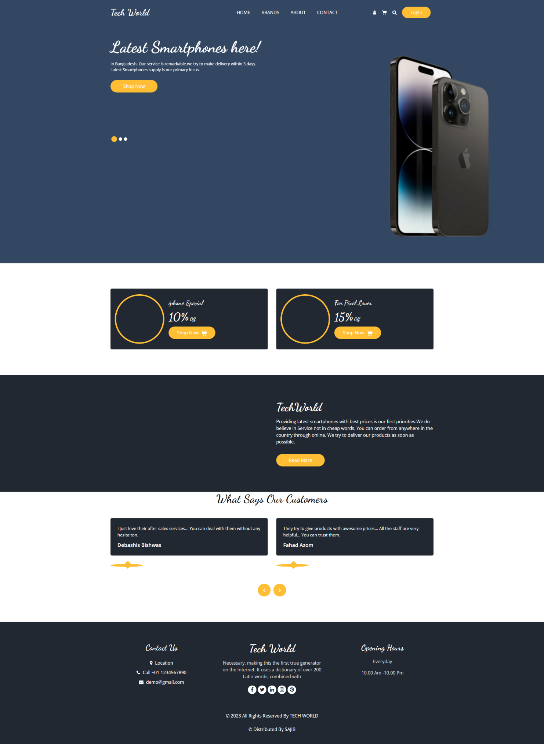

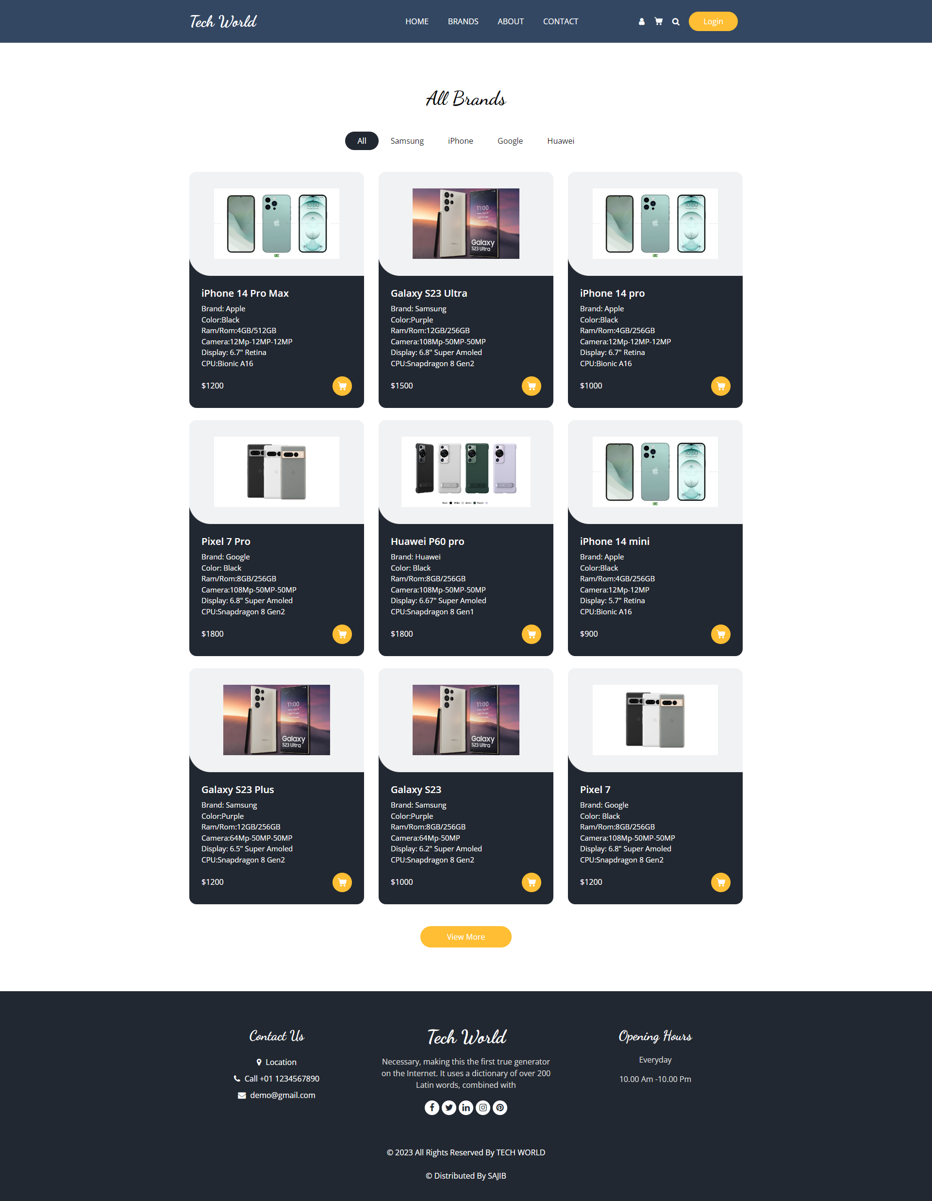

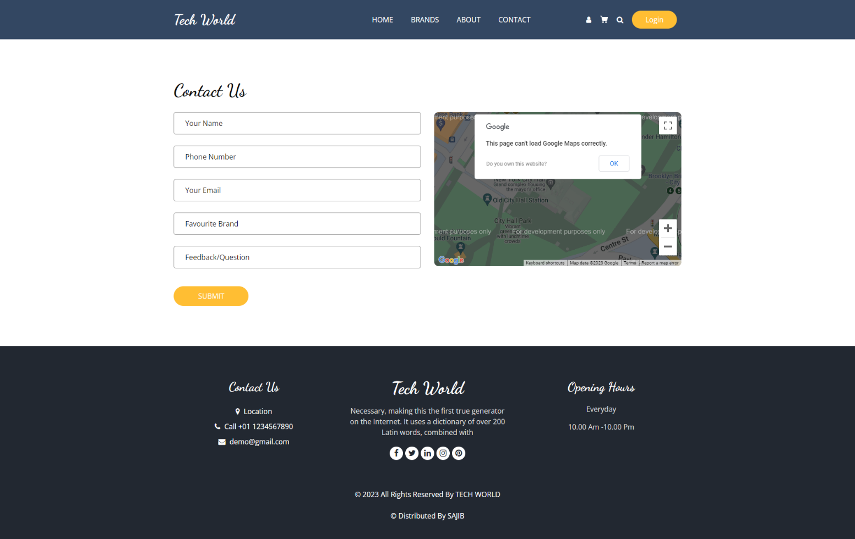

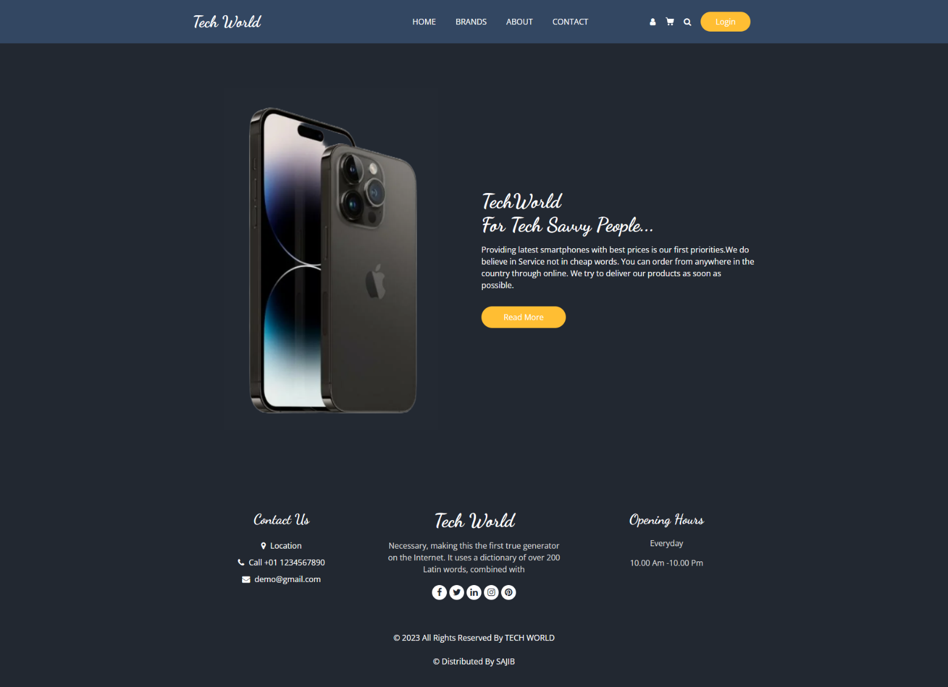

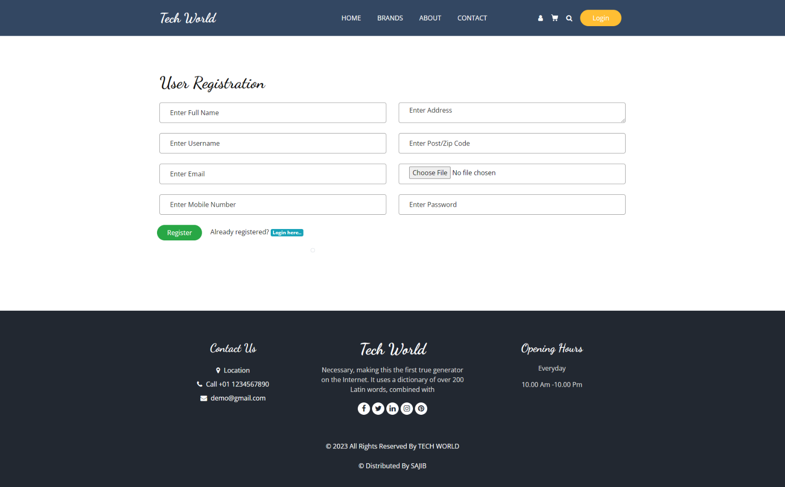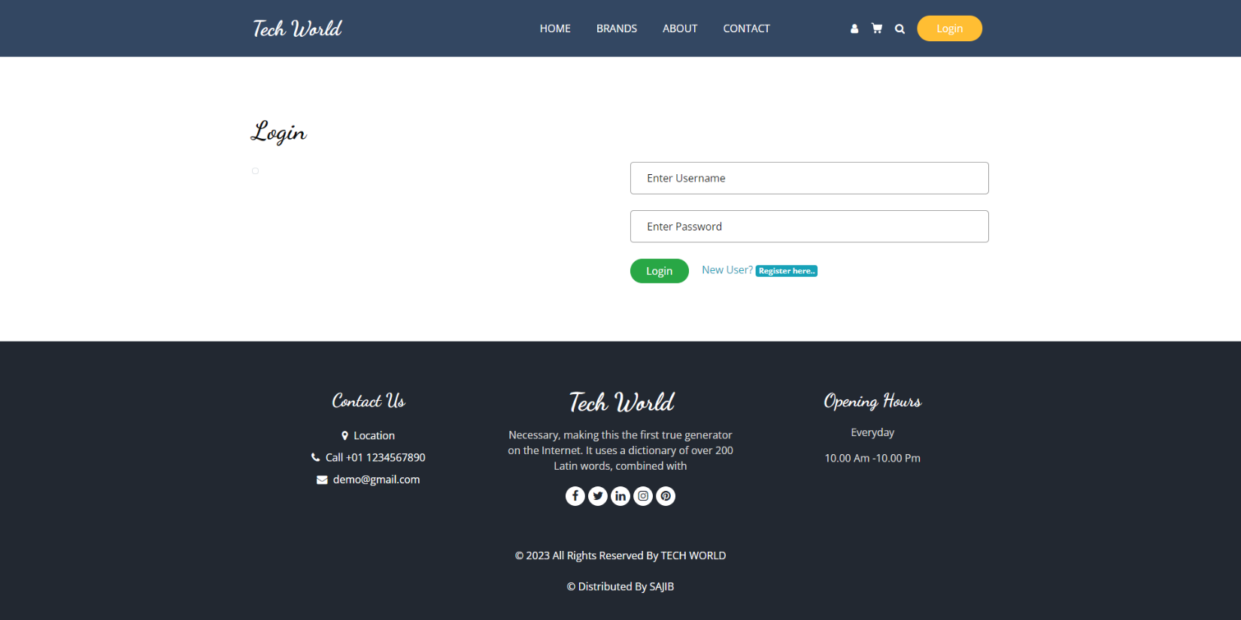

**Diccussion & Conclusion**: By this project, I’ve learnt how to build a website using HTML, CSS, JavaScript, ASP.Net.